2026
Business Information Systems (BIS)

Hossain, Md Alamgir

[Lab 2: Linux Server Setup and AWS Cloud Fundamentals]
This lab focuses on the fundamentals of Linux server management and cloud computing using AWS services. The objective of the lab was to gain hands-on experience in configuring a web server by installing and managing the Apache HTTP server on a Linux-based EC2 instance. Additionally, the lab explores basic AWS services such as EC2, S3, and RDS, highlighting their roles in modern cloud infrastructure. The bonus component of this lab introduces automation through shell scripting, where a command-line tool was developed to simulate cloud storage operations such as uploading, downloading, listing, and deleting files on a remote server using SSH and SCP. Overall, this lab provides practical knowledge of server setup, remote system management, and the foundational concepts of cloud computing.

Contents
Install Apache on an EC2 instance and create a simple web page 1
1. Create a EC2 instance 1
2. Connecting to EC2 Instance 1
3. Installing Apache (httpd) 2
4. Starting Apache Service: 3
5. Locate the folder and file inside the server 4
4. Now we need to start apache, run 6
5. Browse the AWS service offerings and pick 3 6
Optional Bonus (5 Marks) 7

Install Apache on an EC2 instance and create a simple web page
1. Create a EC2 instance (T2.micro with suggested defaults is fine)
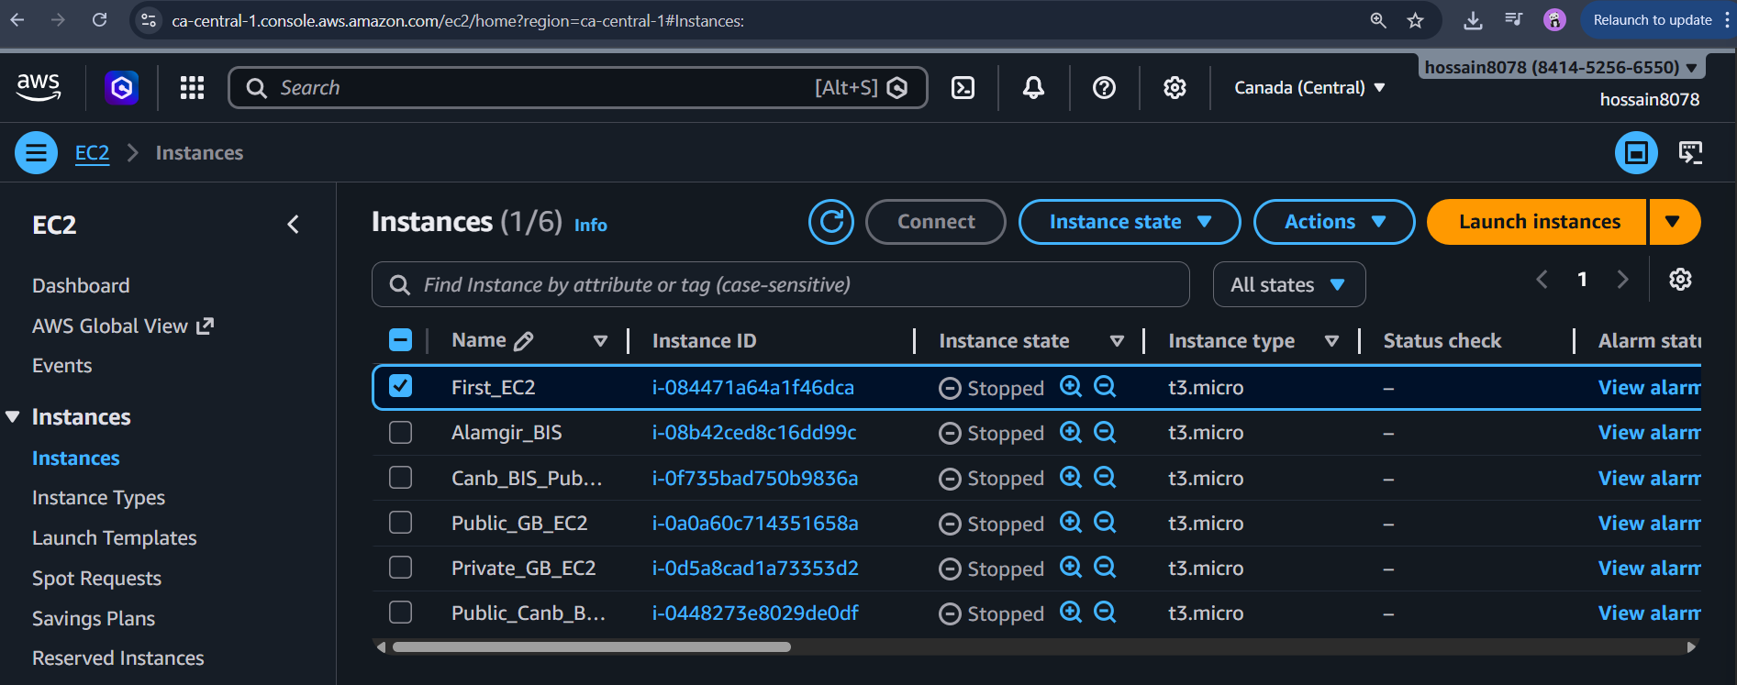

2. Connecting to EC2 Instance
This screenshot shows a successful SSH connection to the EC2 instance. SSH (Secure Shell) is used to securely access and manage remote servers from a local machine. This step confirms that the instance is running and accessible.
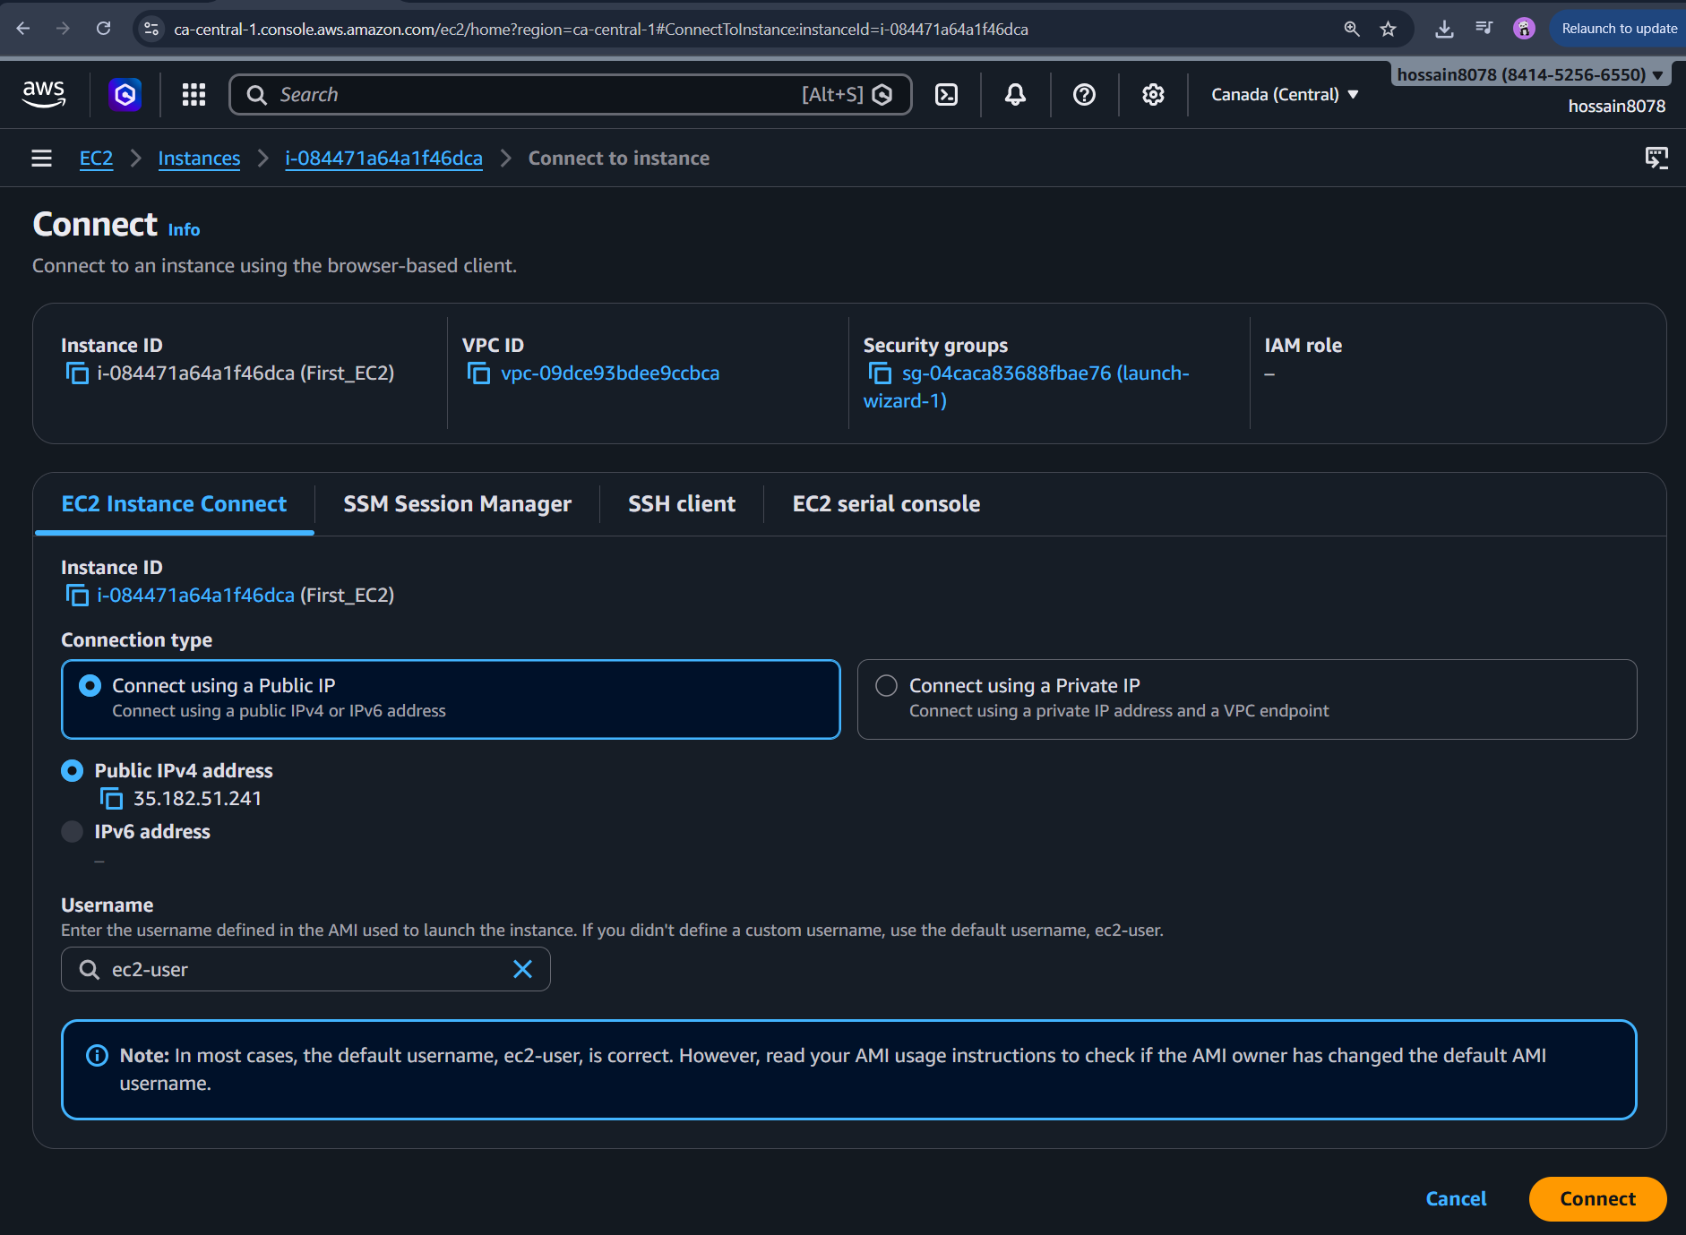sud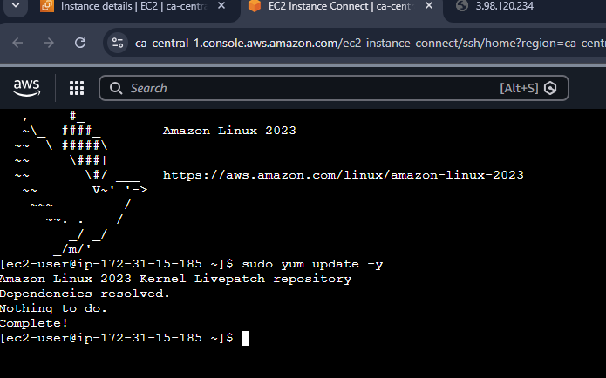
3. Installing Apache (httpd) by using the yum package manager
This screenshot shows the installation of the Apache HTTP server using the package manager. Apache is used to host web pages and handle HTTP requests from clients.

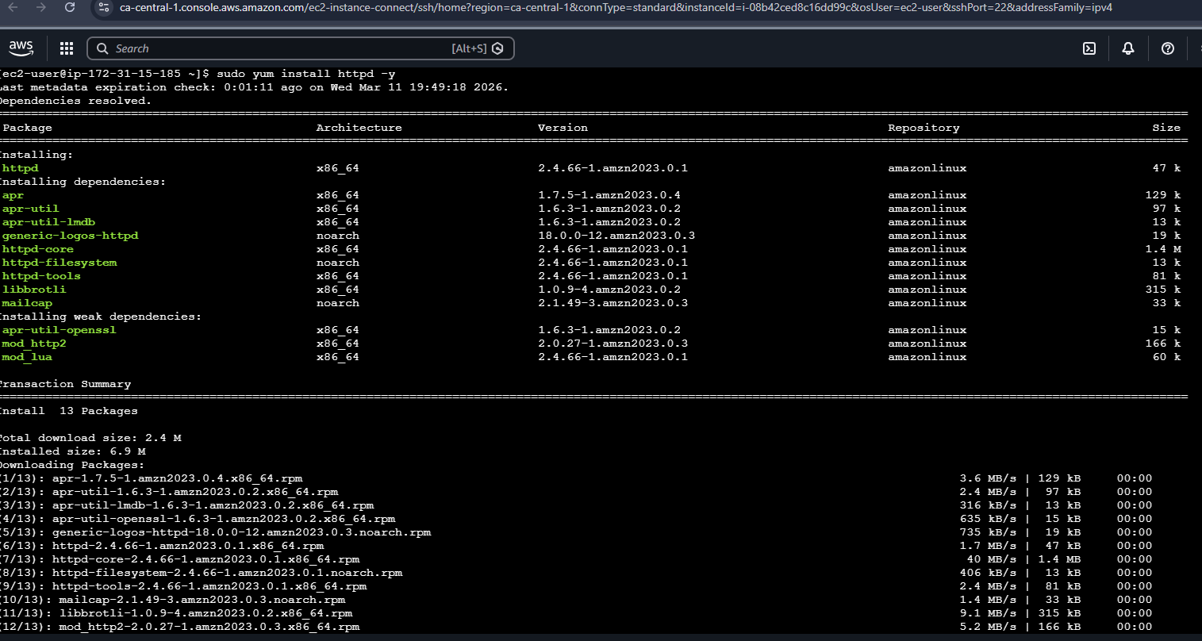
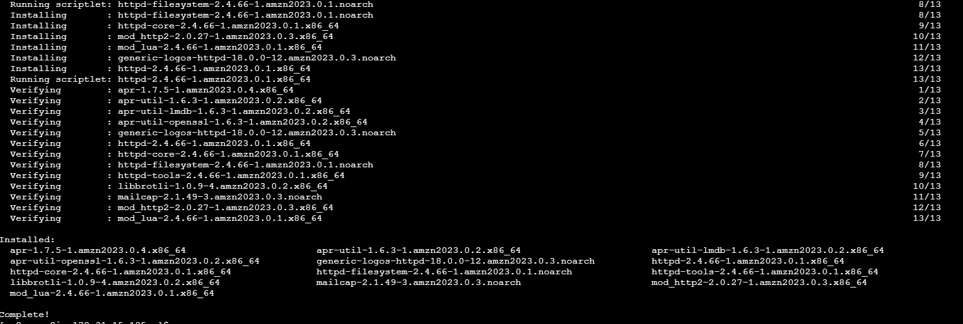
Figure 4: Installing Apache web server

4. Starting Apache Service: Server service starts and checks configuration
The Apache service is started using system commands. This step activates the web server, allowing it to begin serving web content.
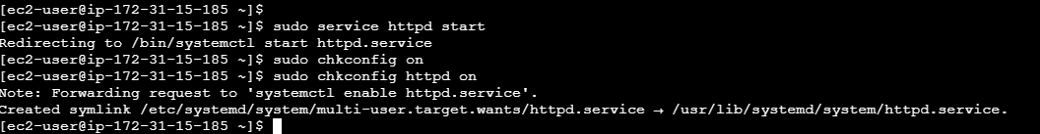
Figure 5: Starting Apache service

5. Locate the folder and file inside the server

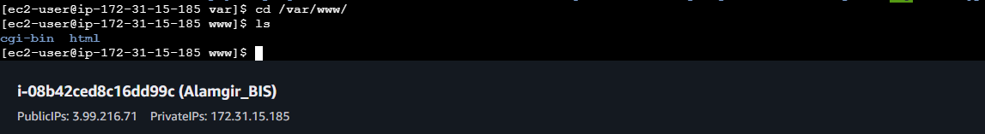

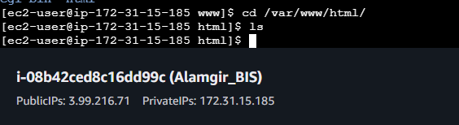

a. What is Root?
In AWS, "root" usually refers to one of two things:
- The Account Root User: The email address used to create the AWS account. it has total control over billing and all resources.
- The OS Root User: The "superuser" inside your Linux EC2 instance who has permission to modify any system file.

b. How to run as Root?
Since AWS EC2 instances usually don't have a root password set, you use sudo:
- Single Command: Type sudo before your command.
  - Example: sudo yum update
- Persistent Session: Type sudo -i to become the root user until you type exit.

3. Now we need to create a quick index.html to prove it works
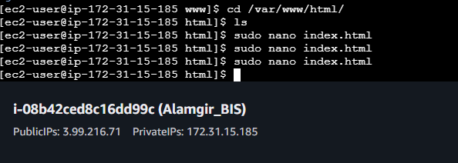
(note: I already have a index.html file in my html folder, so I created a file named index2.html.)
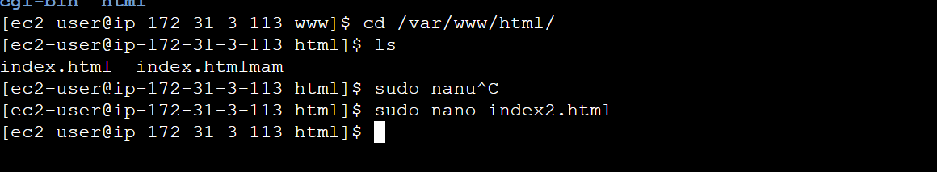

3.a Create index.html that has your name as the body of the page
b. Hint: all files found in /var/www/html is available over port 80
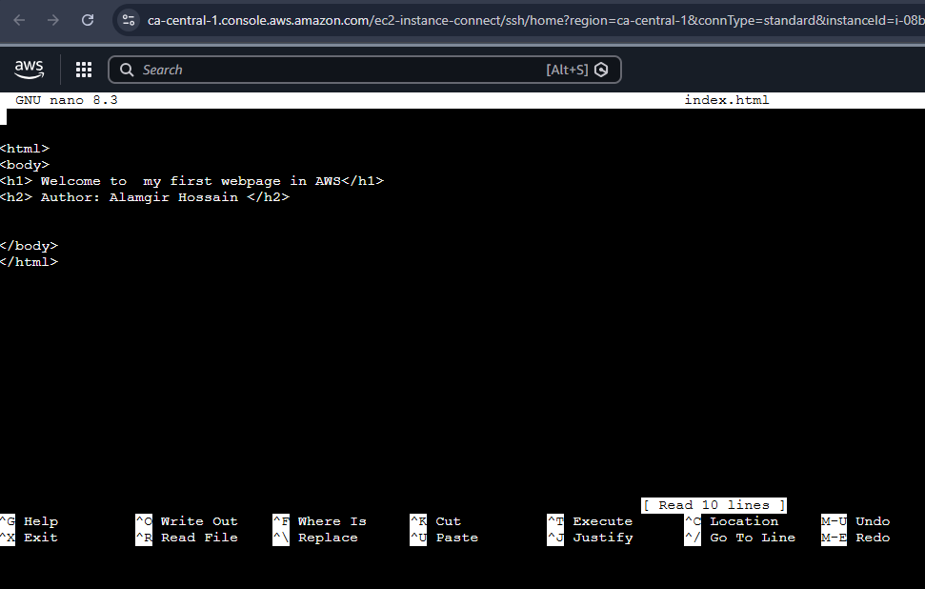
(now, I saved and exit from my index.html page)

Now, I can get my index.html page by my public IPv4 address (http://3.99.216.71)
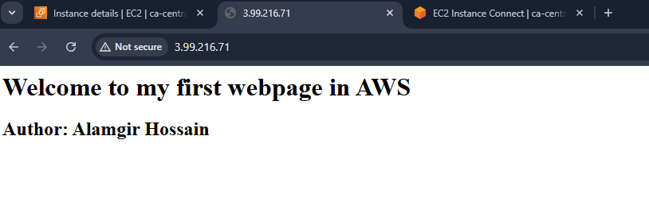

4. Now we need to start apache, run the following commands:
a. sudo service httpd start
b. chkconfig on - this will restart the httpd service if it crashes
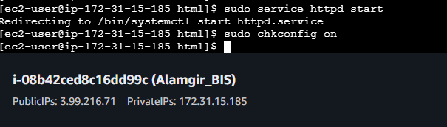

5. Browse the AWS service offerings and pick 3 you find of interest and provide a 2-3 sentence describing a possible use case
1. Amazon S3 (Simple Storage Service)
I can use S3 to store my website's static content, such as images, CSS, or the index.html files I created in the lab. This acts as a highly durable backup for your web files and can even be configured to host a static version of your site if my EC2 instance is down.
2. Amazon EBS (Elastic Block Store)
EBS acts as the "hard drive" for your EC2 instance. In your lab, all the Apache configurations and files are stored here; you can use EBS snapshots to create point-in-time backups of your server so you can quickly restore your web server if you accidentally break a configuration file.
3. Amazon RDS (Relational Database Service)
If you wanted to turn your simple "name" webpage into a dynamic site (like a guestbook or login page), you would use RDS to host a database. It connects directly to your Apache server on EC2, allowing you to store and retrieve data without having to manually install and manage database software yourself.

Optional Bonus (5 Marks)
You are to create a bash script that provides a sort of "command-line Dropbox" if you have access to a remote host running a secure shell (ssh) server (...like in AWS perhaps?). To use this script you will need a directory named cloud inside your HOME directory on the remote host. You can then copy files to (put), copy files from (get), list files in, and delete files in your cloud directory on the remote host. You will use the command ssh and scp to complete the following required functionality.
- Create the Remote Directory: Connect to your AWS EC2 instance and create the folder:
Connect to your AWS EC2 instance and create the folder:
mkdir ~/cloud
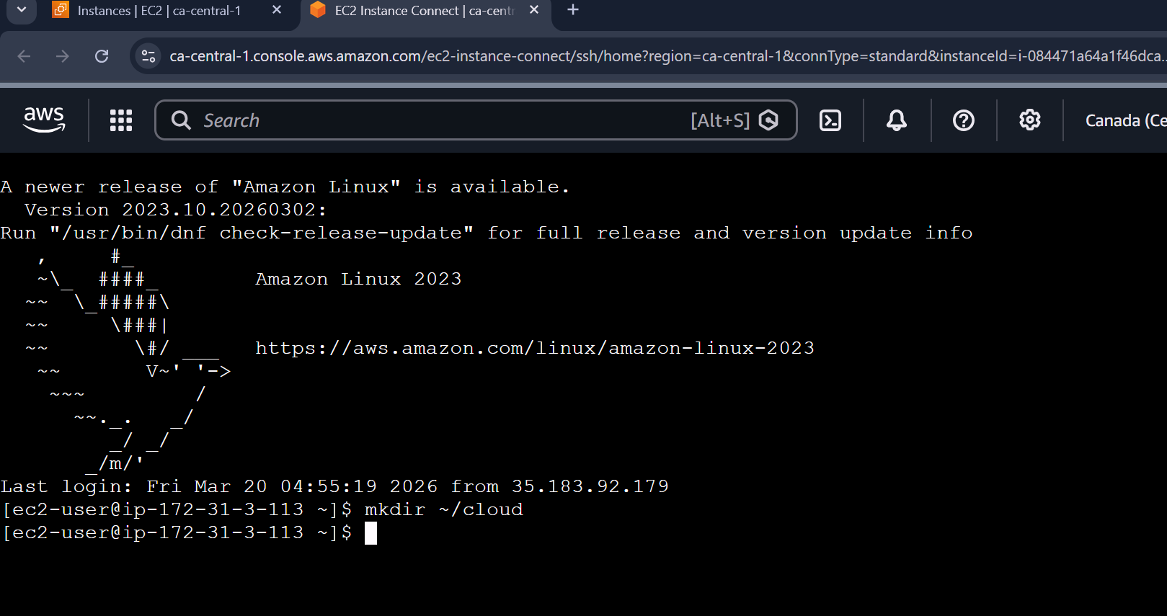
- Create the Script File: On your local machine (the "linuxbox"), create a file named my_cloud:
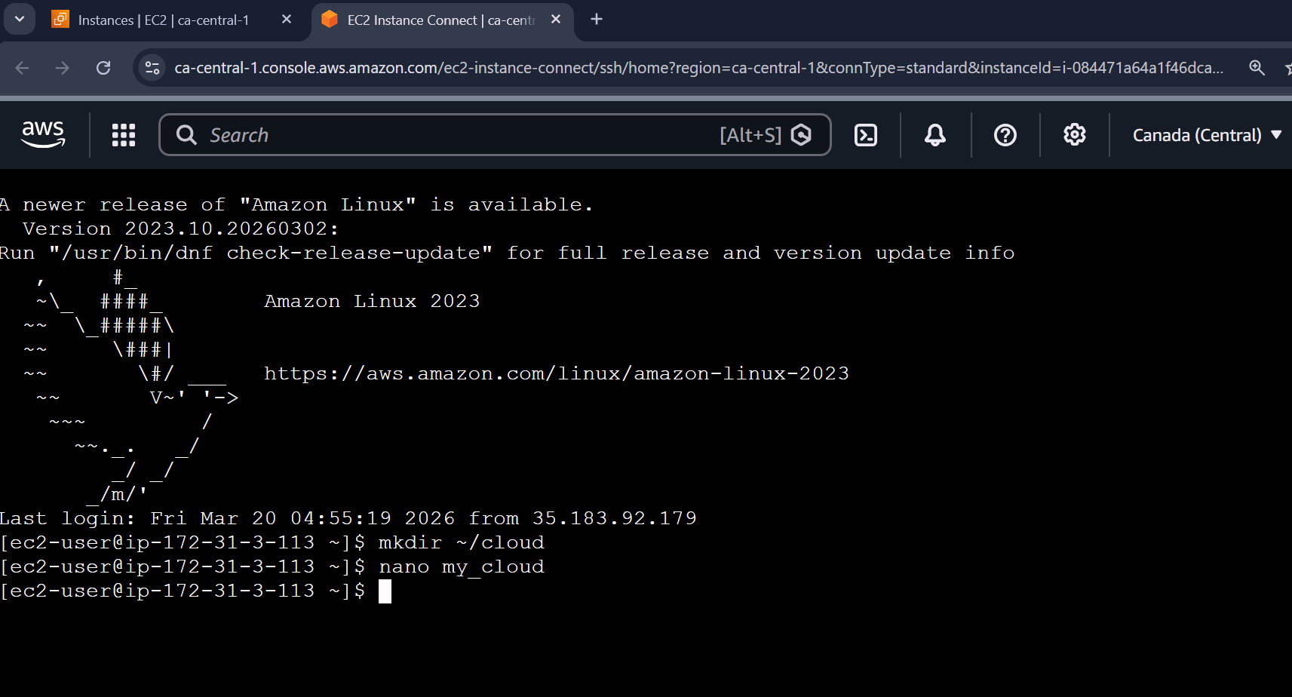

- Make it Executable and run commands in it:
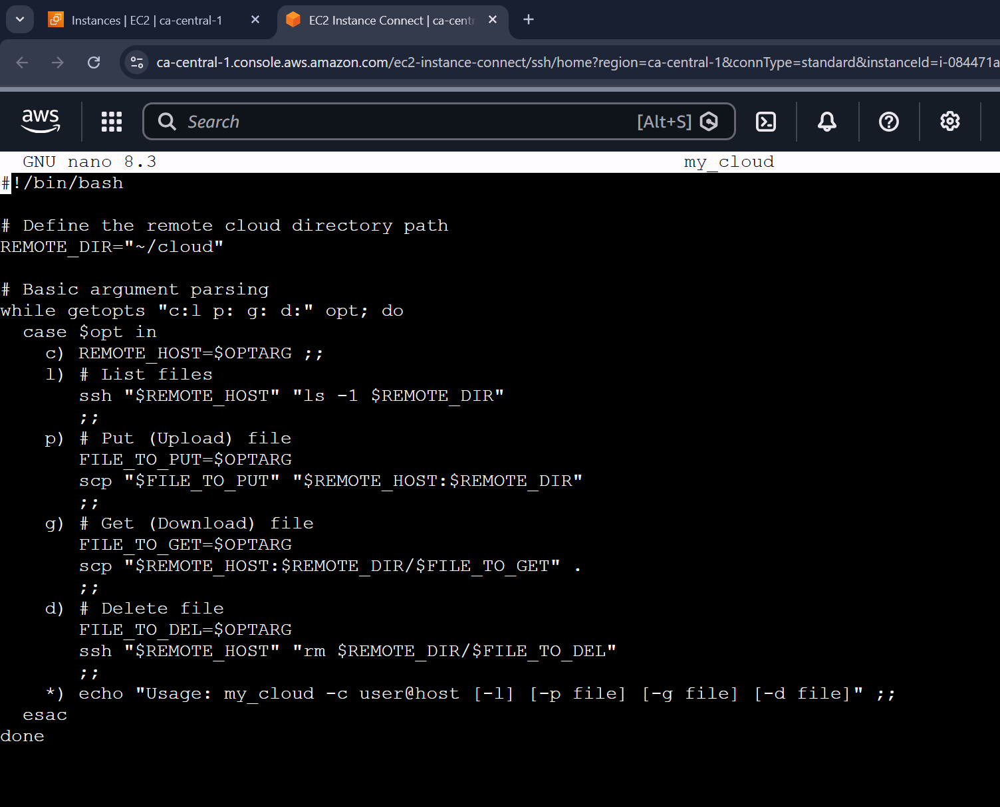
- Run list, upload, download, and delete commands in my_cloud:
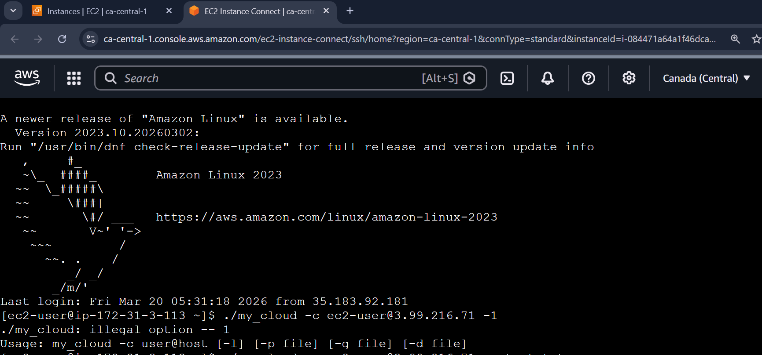
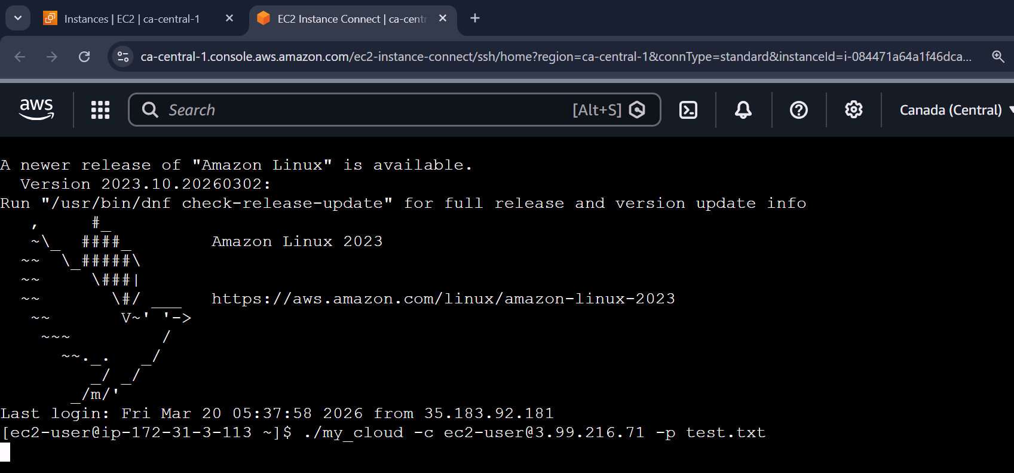
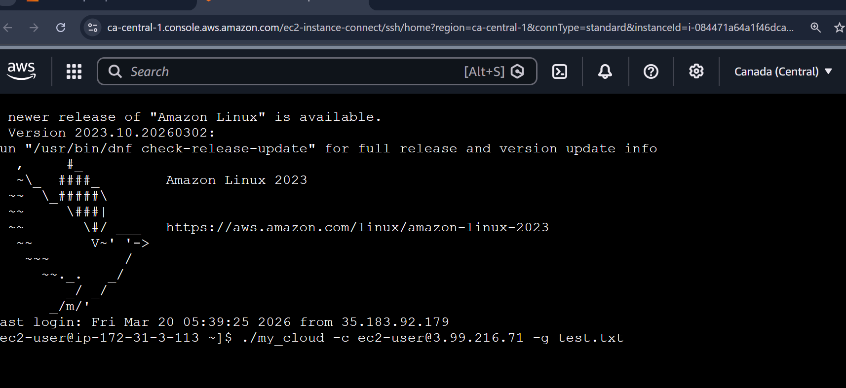
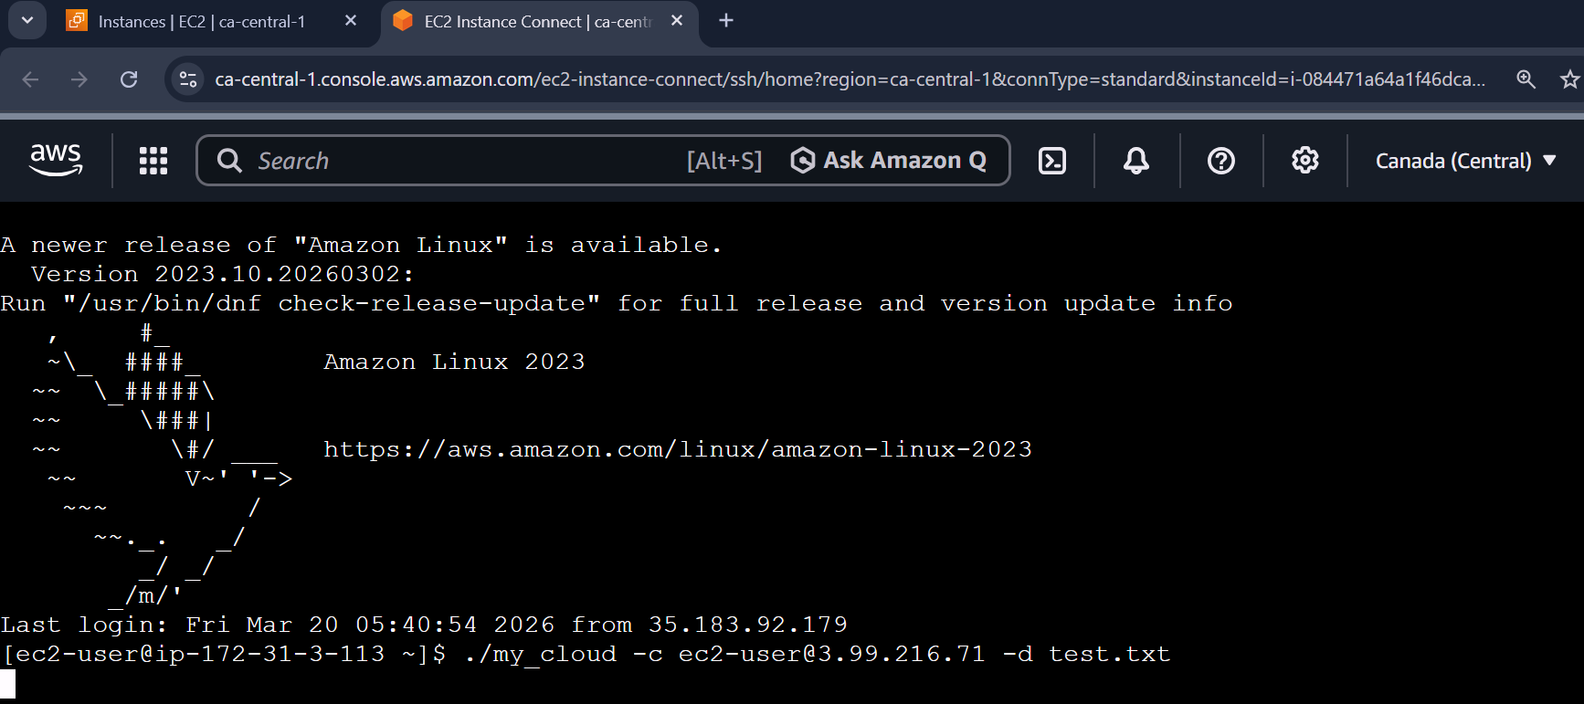
Why this works
- ssh: Executes a command on the remote server and returns the output to your local screen.
- scp: Securely copies files over the network using the same protocol as SSH.
- getopts: A built-in tool that allows the script to recognize flags like -c and -p.

------------------------------------------------------------------------------------------------------------------------------

